Q1) State the benefits of using CSS.

Ans: The benefits of using CSS are:

1. Ease of Maintenance
2. Code Reusability
3. Saves Time
4. Platform Independent
5. Develop Web pages for multiple devices like mobiles, TV, Laptops, PC, Large Screens, etc.
6. Easy to Learn
7. Separates the structure from presentation
8. More Formatting options
9. Easy to Understand

Q2) What are the disadvantages of CSS.

Ans) Disadvantages of CSS is Cross Browser Issues as when a HTML file is being run on different browsers it would give us different results as there are some tags which are not supported by different browser.

Q3) Difference between CSS2 and CSS3.

|  |  |
| --- | --- |
| **CSS2** | **CSS3** |
| There is no backward Compatibility Issue | There is backward Compatibility Issue |
| Only Web safe fonts are used | Google Fonts or stylized fonts can be used |
| In CSS2, splitting a text into multiple sections required complex coding | In CSS3, it is quite simple to split the text into multiple sections |
| CSS2, doesn’t support border box property | CSS3, supports the border box property |
| For rounded borders, the coding was complex | It is simple in CSS3 |
| It has less selectors than the CSS3 | CSS3 introduced more selectors. |

Q4) What do you understand by CSS opacity?

* Opacity in CSS can be understood as the transparency of an image in CSS.
* Opacity in CSS can be anywhere between 0 to 1.
* The closer it is to the 0 the more transparent image is.
* When the image opacity in CSS is zero, then the image is completely transparent.
* When the image opacity is one, then the image is opaque.
* Code and Output: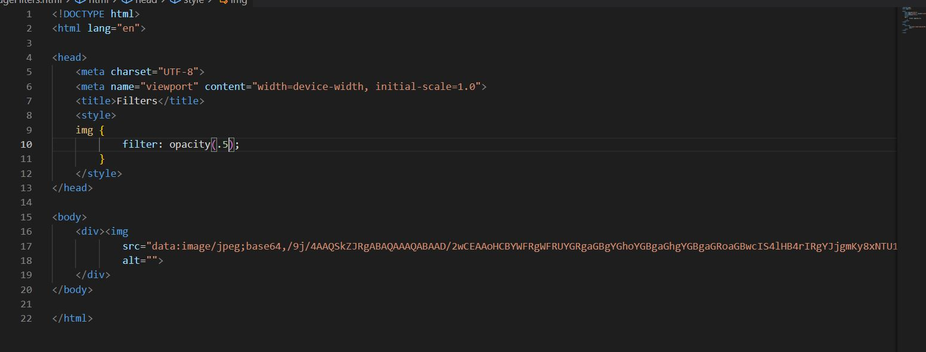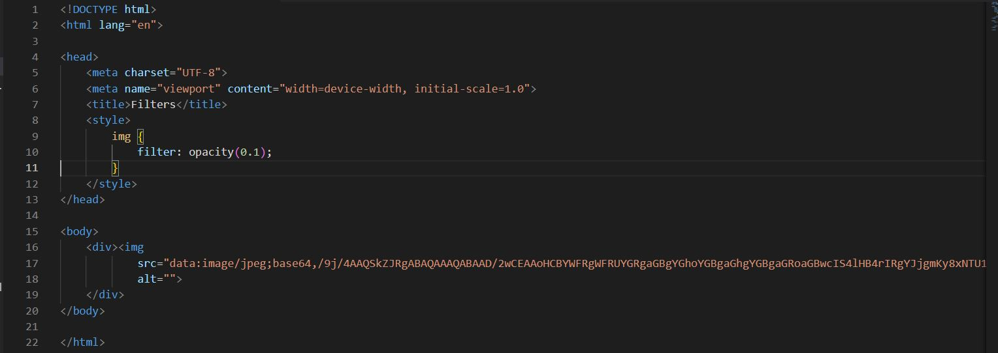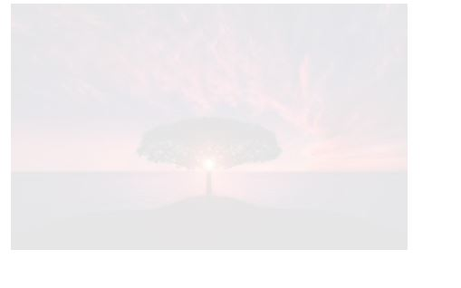
* Here Opacity is 0.1 so the image is nearly transparent.

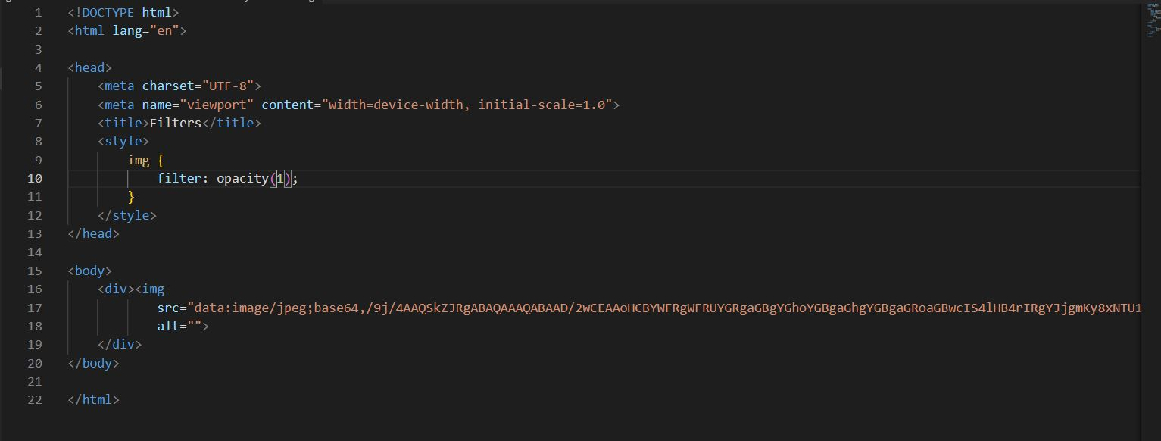



Q5) How can the background color of an element be changed?

* Background color of an element could be changed by using a CSS property called background-color: colorname;
* Code :

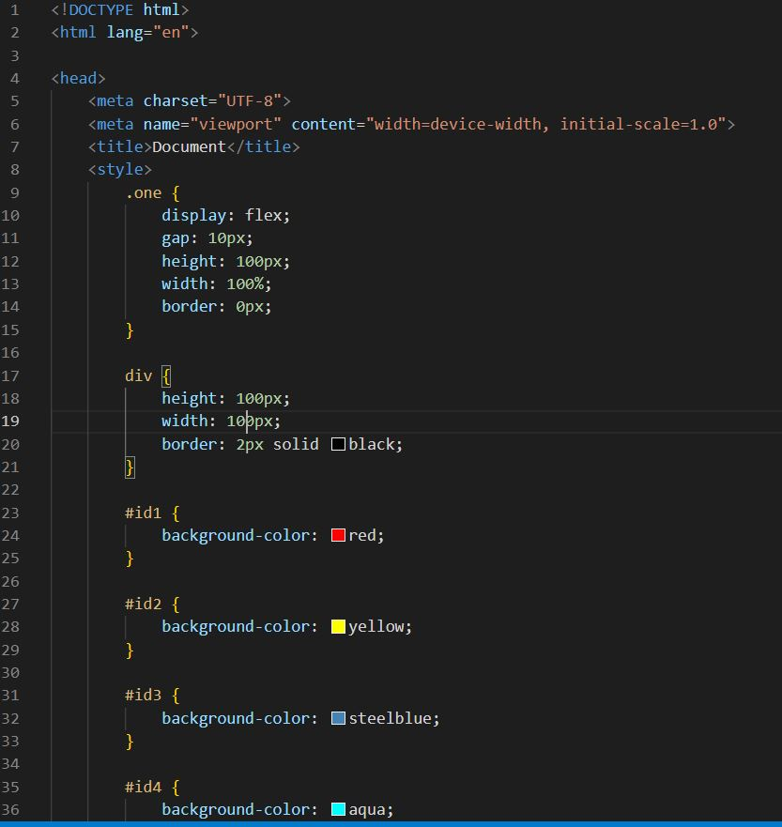

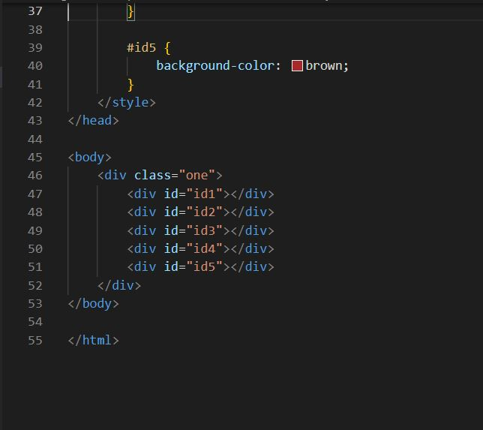

* Output:

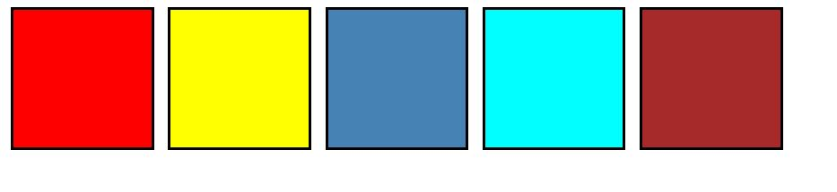

Q7) Name a few CSS style components.

* There are three components of CSS style tag.

1. Selector
2. Property
3. Value

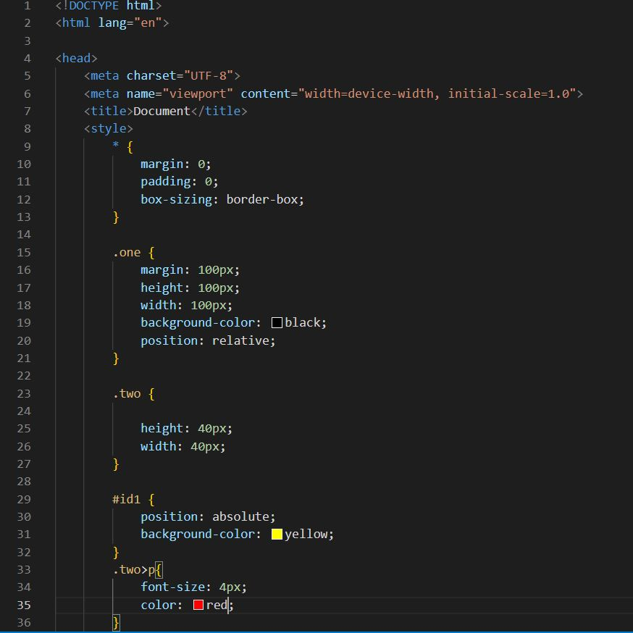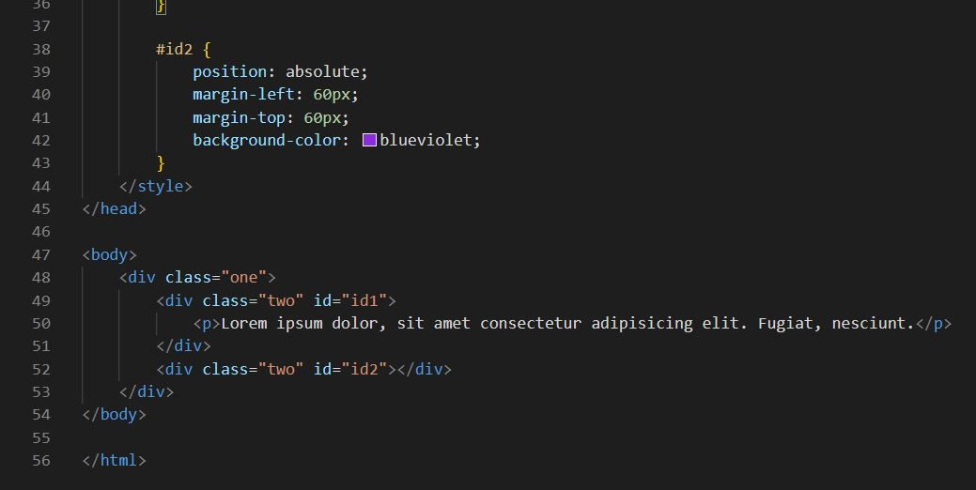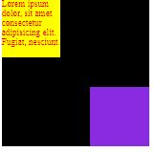

* In this code, we can see the use of selectors like **universal selector, class selector, id selector and child selector.**

|  |  |  |
| --- | --- | --- |
| **Selector** | **Symbol** | **Description** |
| Class | . | Selects all elements in the class name |
| ID | # | Selects all elements in the ID |
| Element | No symbol | Selects all the elements in the element |
| Group | , | Selects all the elements in the tags separated by the comma symbol. |

* You must have observed that in the CSS code, we have used things like **background-color, color, font-size, height, width, display**, etc. These things are called **properties**.
* And these properties have a matching value ahead of them which are called **Values**.

Example:

*background-color*: **red**;

*font-size*: **4px**;

*color*: **green**;

*height*: **100px**;

*width*: **100px**;

**Text in bold are the values while the text in the italic are the properties.

Q8) How can image repetition of the backup be controlled?

* Image repletion can be controlled in the background by using a CSS property called

‘background-repeat’.

* background-repeat has several values namely

1. Inherit
2. None
3. Repeat-x
4. Repeat-y
5. Repeat
6. Round
7. Space
8. Initial
9. Unset

* For example, in the following code we want to have an image repeating only horizontally, we will use value **repeat-x**.

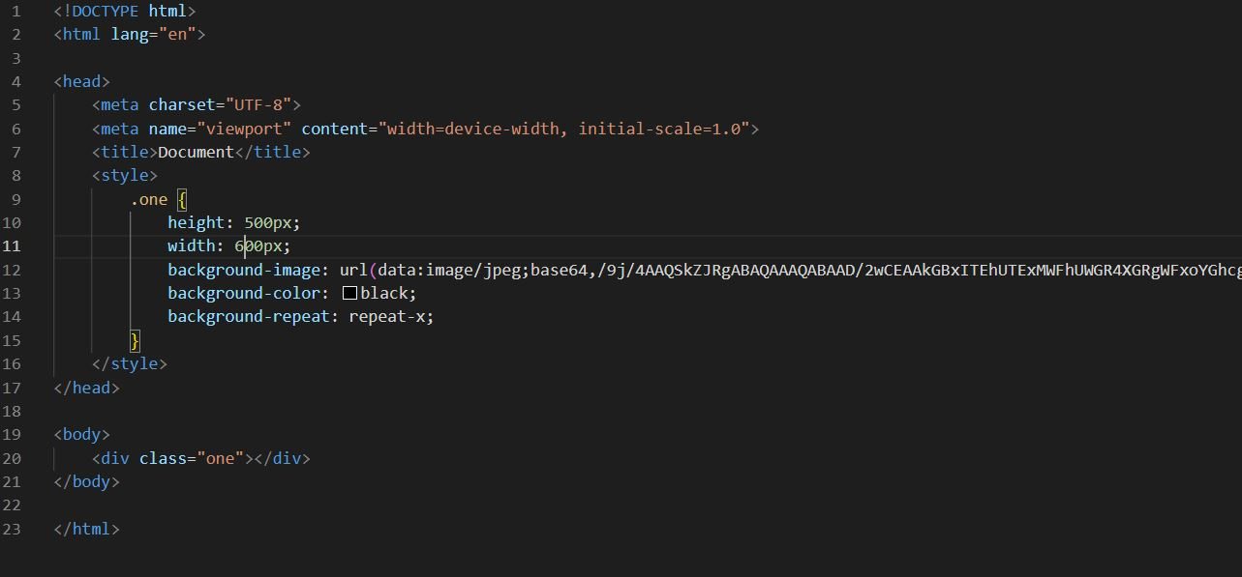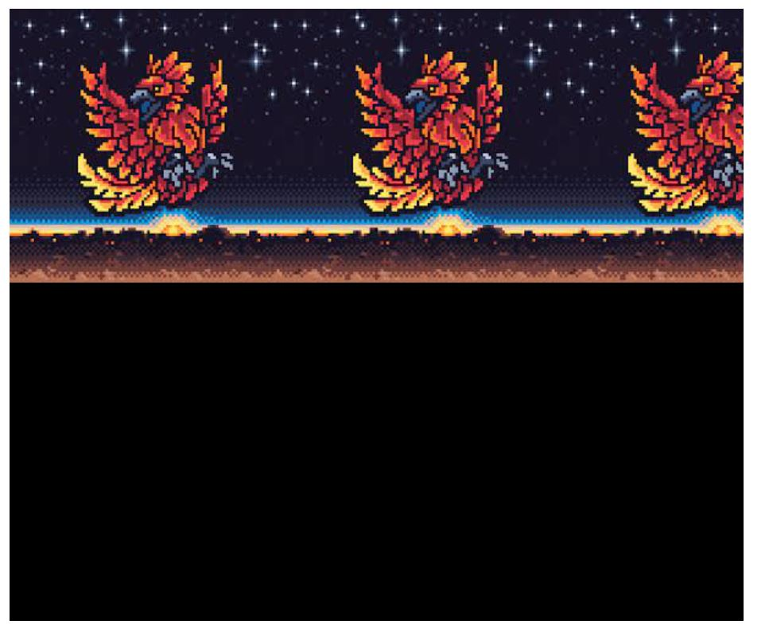

* In this snippet we will see the usage of **repeat-y**.

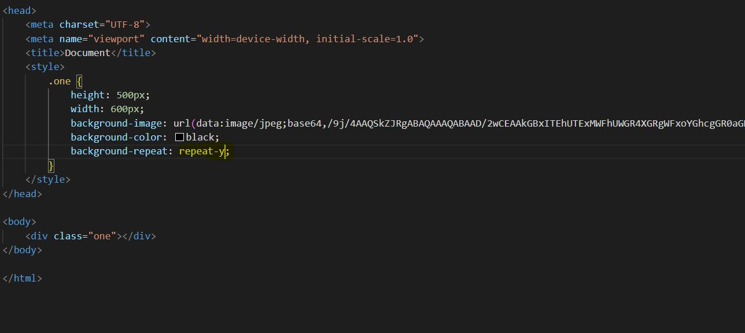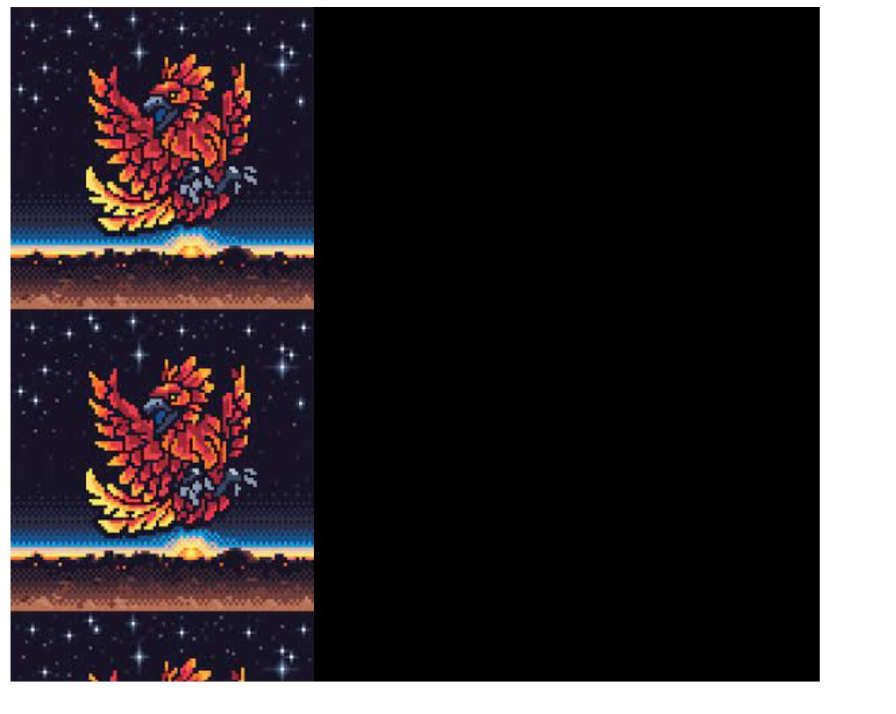

* In this code, we will see the output for **repeat**.

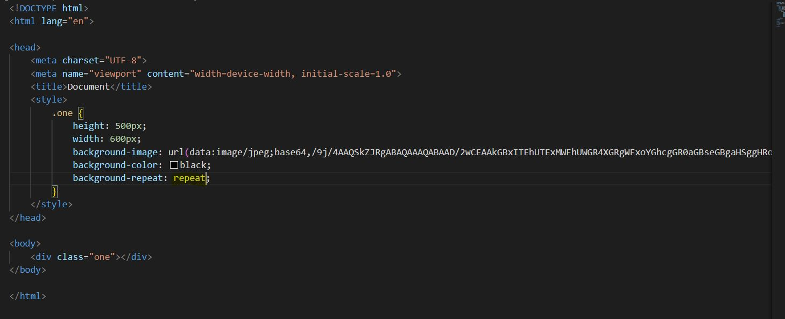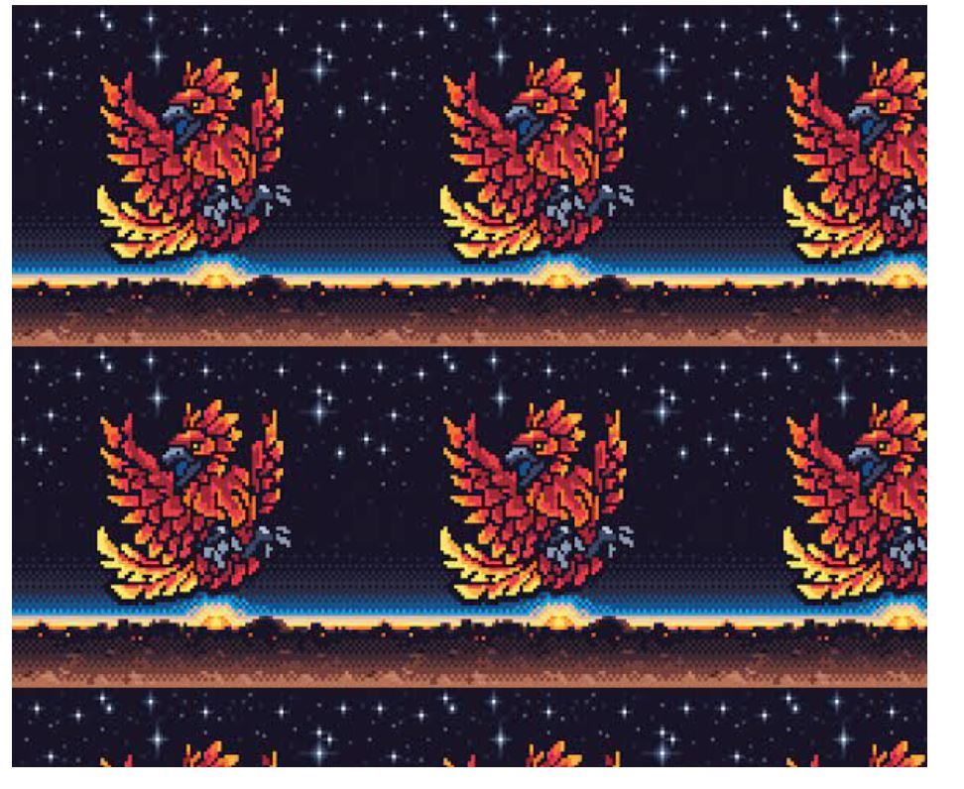

* In this code we will see the code for **no-repeat.**

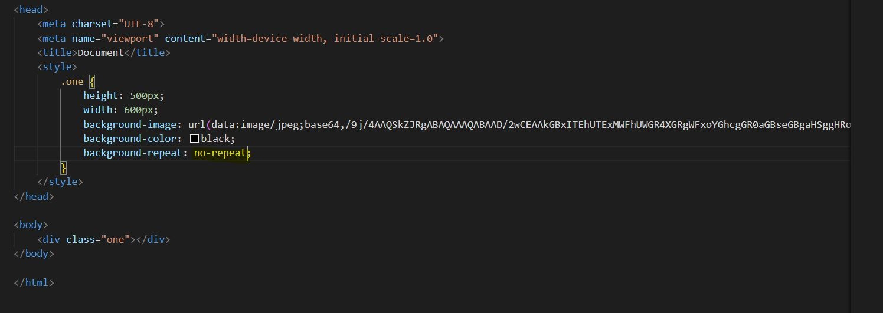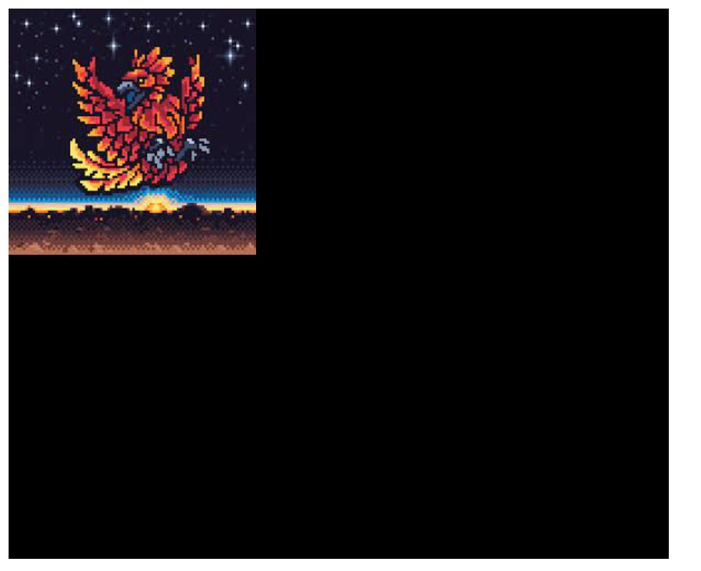

Q9) What is the use of the background-position property?

* The background-position property od CSS is used to set the starting position of a background image.
* The background image is at top-left position by default. It is repeated horizontally and vertically.
* Code:

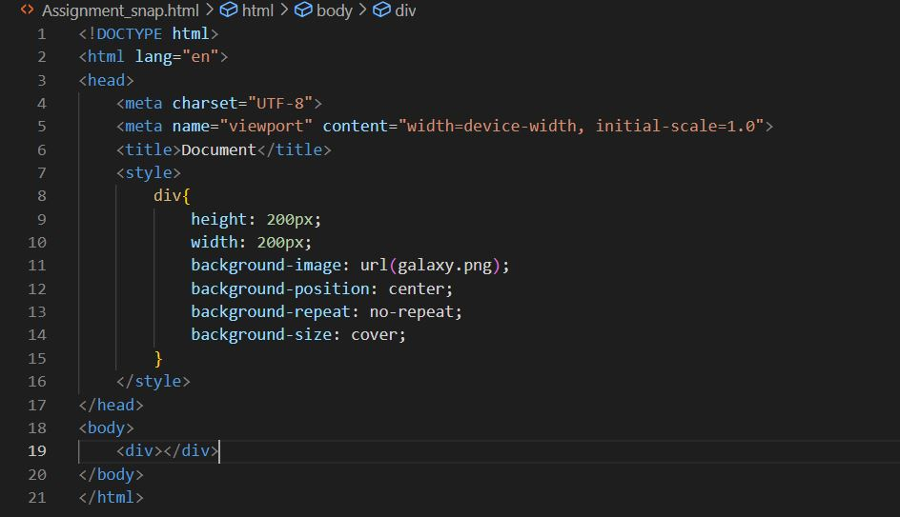

** Background Position as Center**

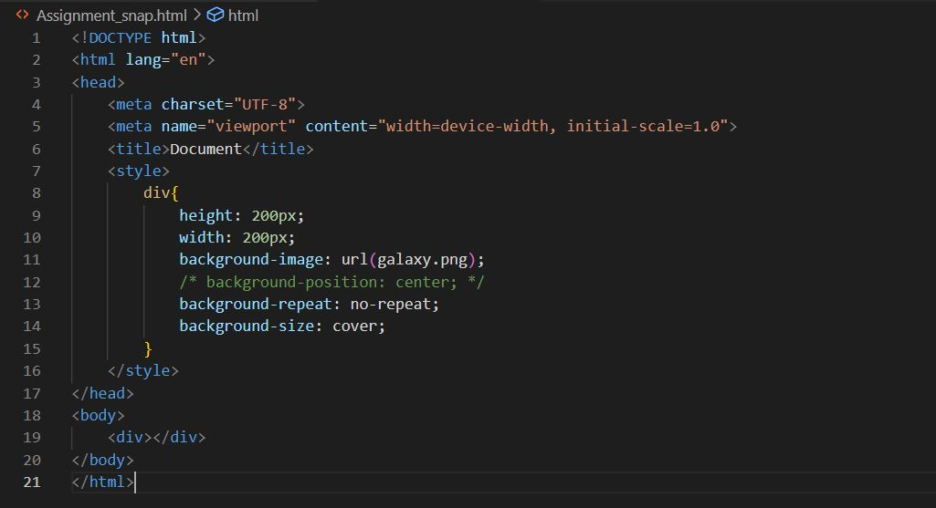 **Background Position is Default i.e. top-left side**

Q10) Which property controls the image scroll in the background?

* The background-attachment property sets whether a background image scrolls with the rest of the page, or is fixed.

|  |  |
| --- | --- |
| Value | Description |
| Scroll | The background image will scroll with the page. |
| Fixed | The background image will not scroll with the page |
| Initial | Sets this property to its default value. |
| Inherit | Inherits the property value from the parent |
| Local | The background image will scroll with element’s content |

Q11) How to center block elements using CSS1?

* To center a block element using CSS1, you can use the margin property and set the left and right margins to "auto". This is done using the CSS rule

**margin: 0 auto;**

* The "auto" property value will automatically set the margin so that the block element is placed in the center. This method calculates equal margins on both sides, pushing the element to the center of its containing parent.
* We can also center the block elements using the <center> tag.

Q12) What are the ways to integrate CSS as a web page?

* There are 3 types by which we can integrate CSS to a webpage
* Types:

1. Inline
2. Internal
3. External

* Inline CSS : It refers to the the CSS written inside the dag in the HTML page.
* Internal CSS: In the internal CSS, we use <style> tag inside the document.
* External CSS: In the external CSS, we create a CSS file with extension ‘.css’ and then link the file to the HTML document using link tag.
* Here are some Examples for it.

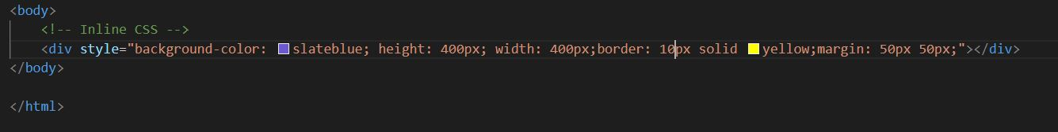

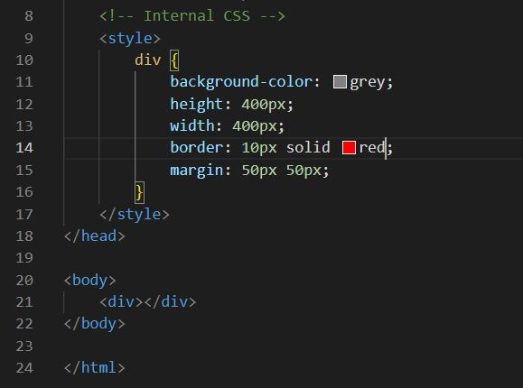 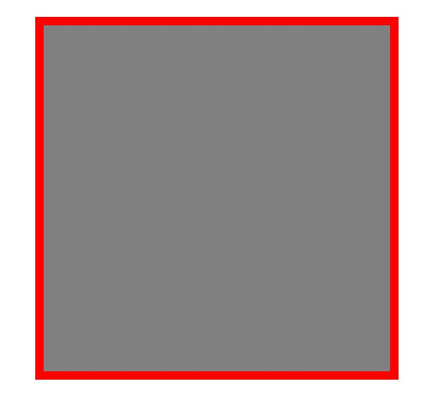

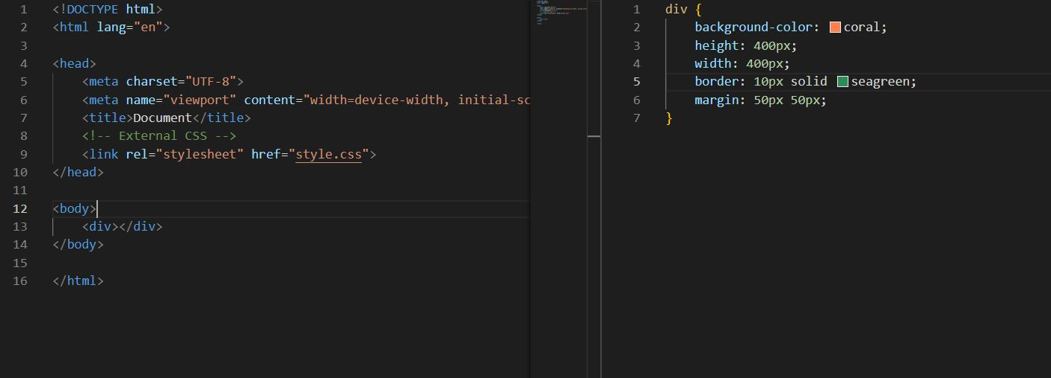



Q13) How to maintain the CSS specifications?

* CSS specifications are maintained by WWW Consortium. They tell us how every browsers interacts with CSS. Every browsers have inconsistencies with CSS and some support other features while not supporting some another features.

Q14) What is embedded style sheets?

* Embedded style sheets stand are also known as Internal CSS.
* With the help of Embedded Style Sheets we do not have to load the CSS document every time and also it takes less time for deploying the HTML sheet. 



Q15) What are the external style sheets?

* External Style Sheets are a type of CSS by which CSS could be applied to an HTML file.
* We create an .css file and link the file to HTML file using <link> tag.



Q16) What are the media types allowed by CSS?

* There are 10 types of media allowed by CSS

1. All

* Suitable for all media types

1. Aural

* Intended for speech synthesizers.

1. Braille

* Intended for braille tactile feedback devices.

1. Embossed

* Intended for paged braille printers.

1. Handheld

* Intended for handheld devices (typically small screen, monochrome, limited bandwidth).

1. Print

* Intended for paged, opaque material and for documents viewed on screen in print preview mode. Please consult the section on paged media.

1. Projection

* Intended for projected presentations, for example projectors or print to transparencies. Please consult the section on paged media.

1. Screen

* Primarily for Computer Screens

1. TV

* Intended for Televison.

1. tty

* Intended for media using a fixed-pitch character grid, such as teletypes, terminals, or portable devices with limited display capabilities.

Q17) What is the meaning of the CSS selector?

* A CSS selector is the first part of a CSS Rule. It is a pattern of elements and other terms that tell the browser which HTML elements should be selected to have the CSS property values inside the rule applied to them. The element or elements which are selected by the selector are referred to as the subject of the selector.
* Types of CSS Selectors

1. Class Selector (.)
2. ID Selector (#)
3. Child Selector (>)
4. Universal Selector (*)
5. Element Selector (h1)
6. Multiple Selector (,)
7. Adjacent Sibling Selector (+)
8. Pseudo Selector ( a:hover )
9. Descendent Selectors( p .one )

Q18) What are the advantages and disadvantages of using external style sheets?

* **The advantages of External Style Sheets are as follows :**

1. With the help of External Style Sheets, the styles of numerous documents can be organized from one single file.
2. In External Style Sheets, Classes can be made for use on numerous HTML element types in many forms of the site.
3. In complex contexts, Methods like selector and grouping can be implemented to apply styles.

* **The disadvantages of External Style Sheets are as follows :**

1. An extra download is essential to import style information for each file.
2. The execution of the file may be deferred till the external style sheet is loaded.
3. While implementing style sheets, we need to test Web pages with multiple browsers in order to check compatibility issues.

Q19) What is the rule set?

* 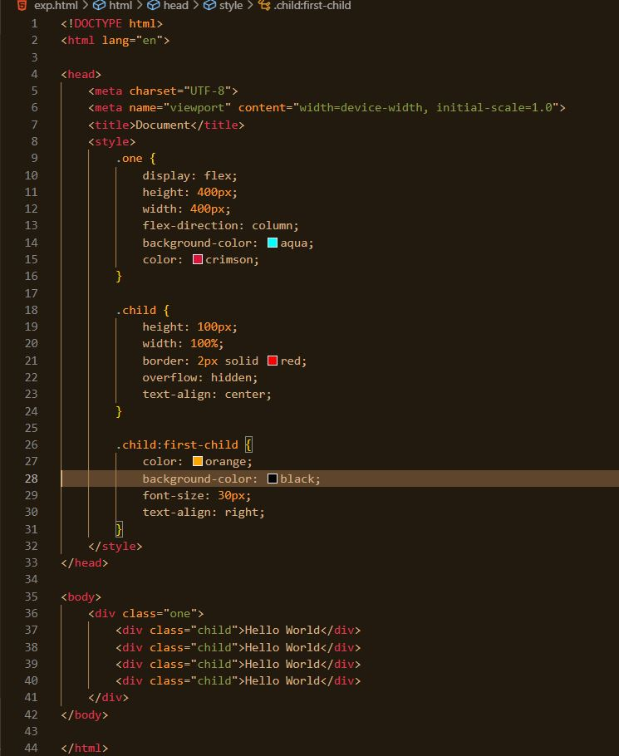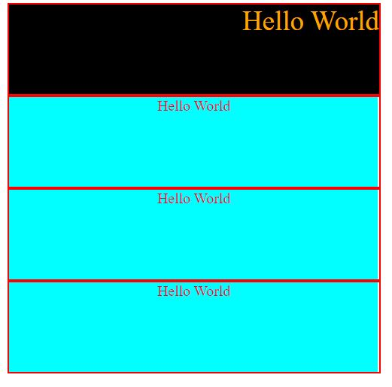

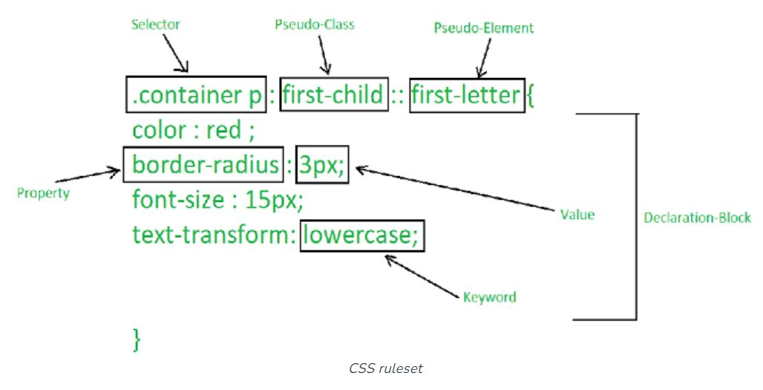

* The “.” in the beginning indicates that the rule created will be a class, also “container” indicates the name of the selector.
* Similarly “first-child” indicates the pseudo class  and elements inside curly brackets are elements of a declaration block, which contains some CSS properties and their corresponding values. The CSS ruleset will be applied when the selector name is called on the main HTML page.
* CSS Ruleset is the main building block of the CSS stylesheet.
* For example the .one class will have its first child different CSS applied.